

**ASSIGNMENT 7**

[Design of a combinational logic circuit for **3-BIT ADDER AND SUBTRACTOR** using 2 input NAND GATES]



**NAME: ROHIT SADHU**

**ROLL NO.: 002010501074**



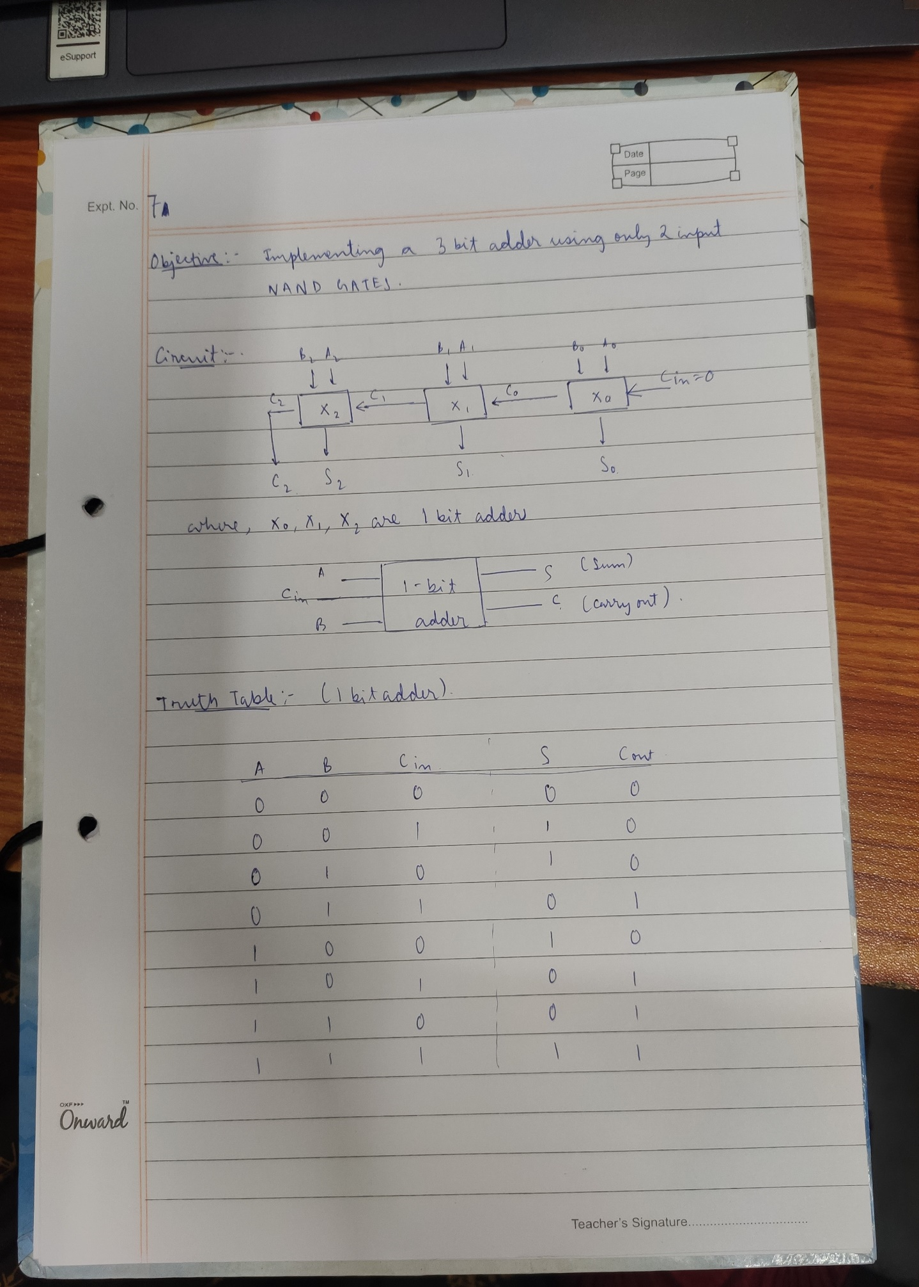

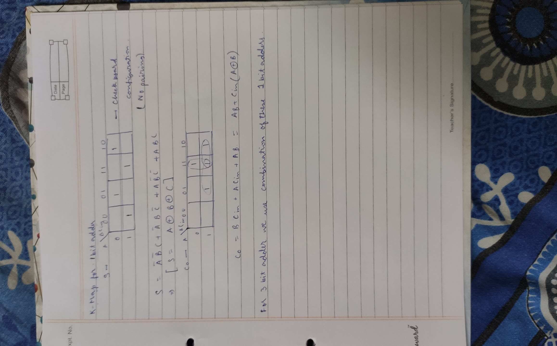

**CIRCUIT DIAGRAM:**

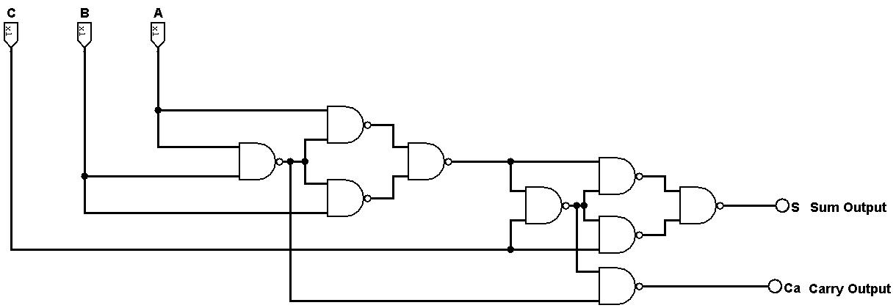**1 BIT FULL ADDER:**

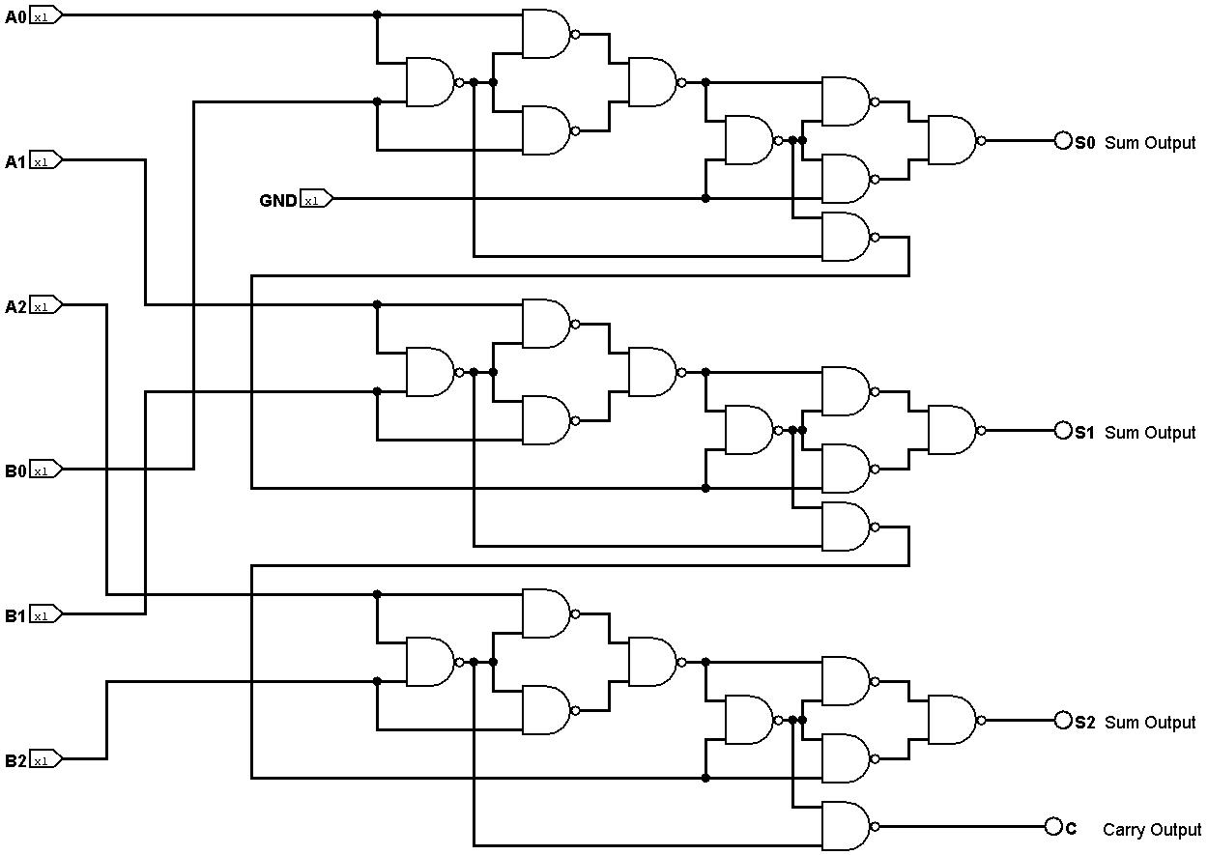**3 BIT FULL ADDER:**

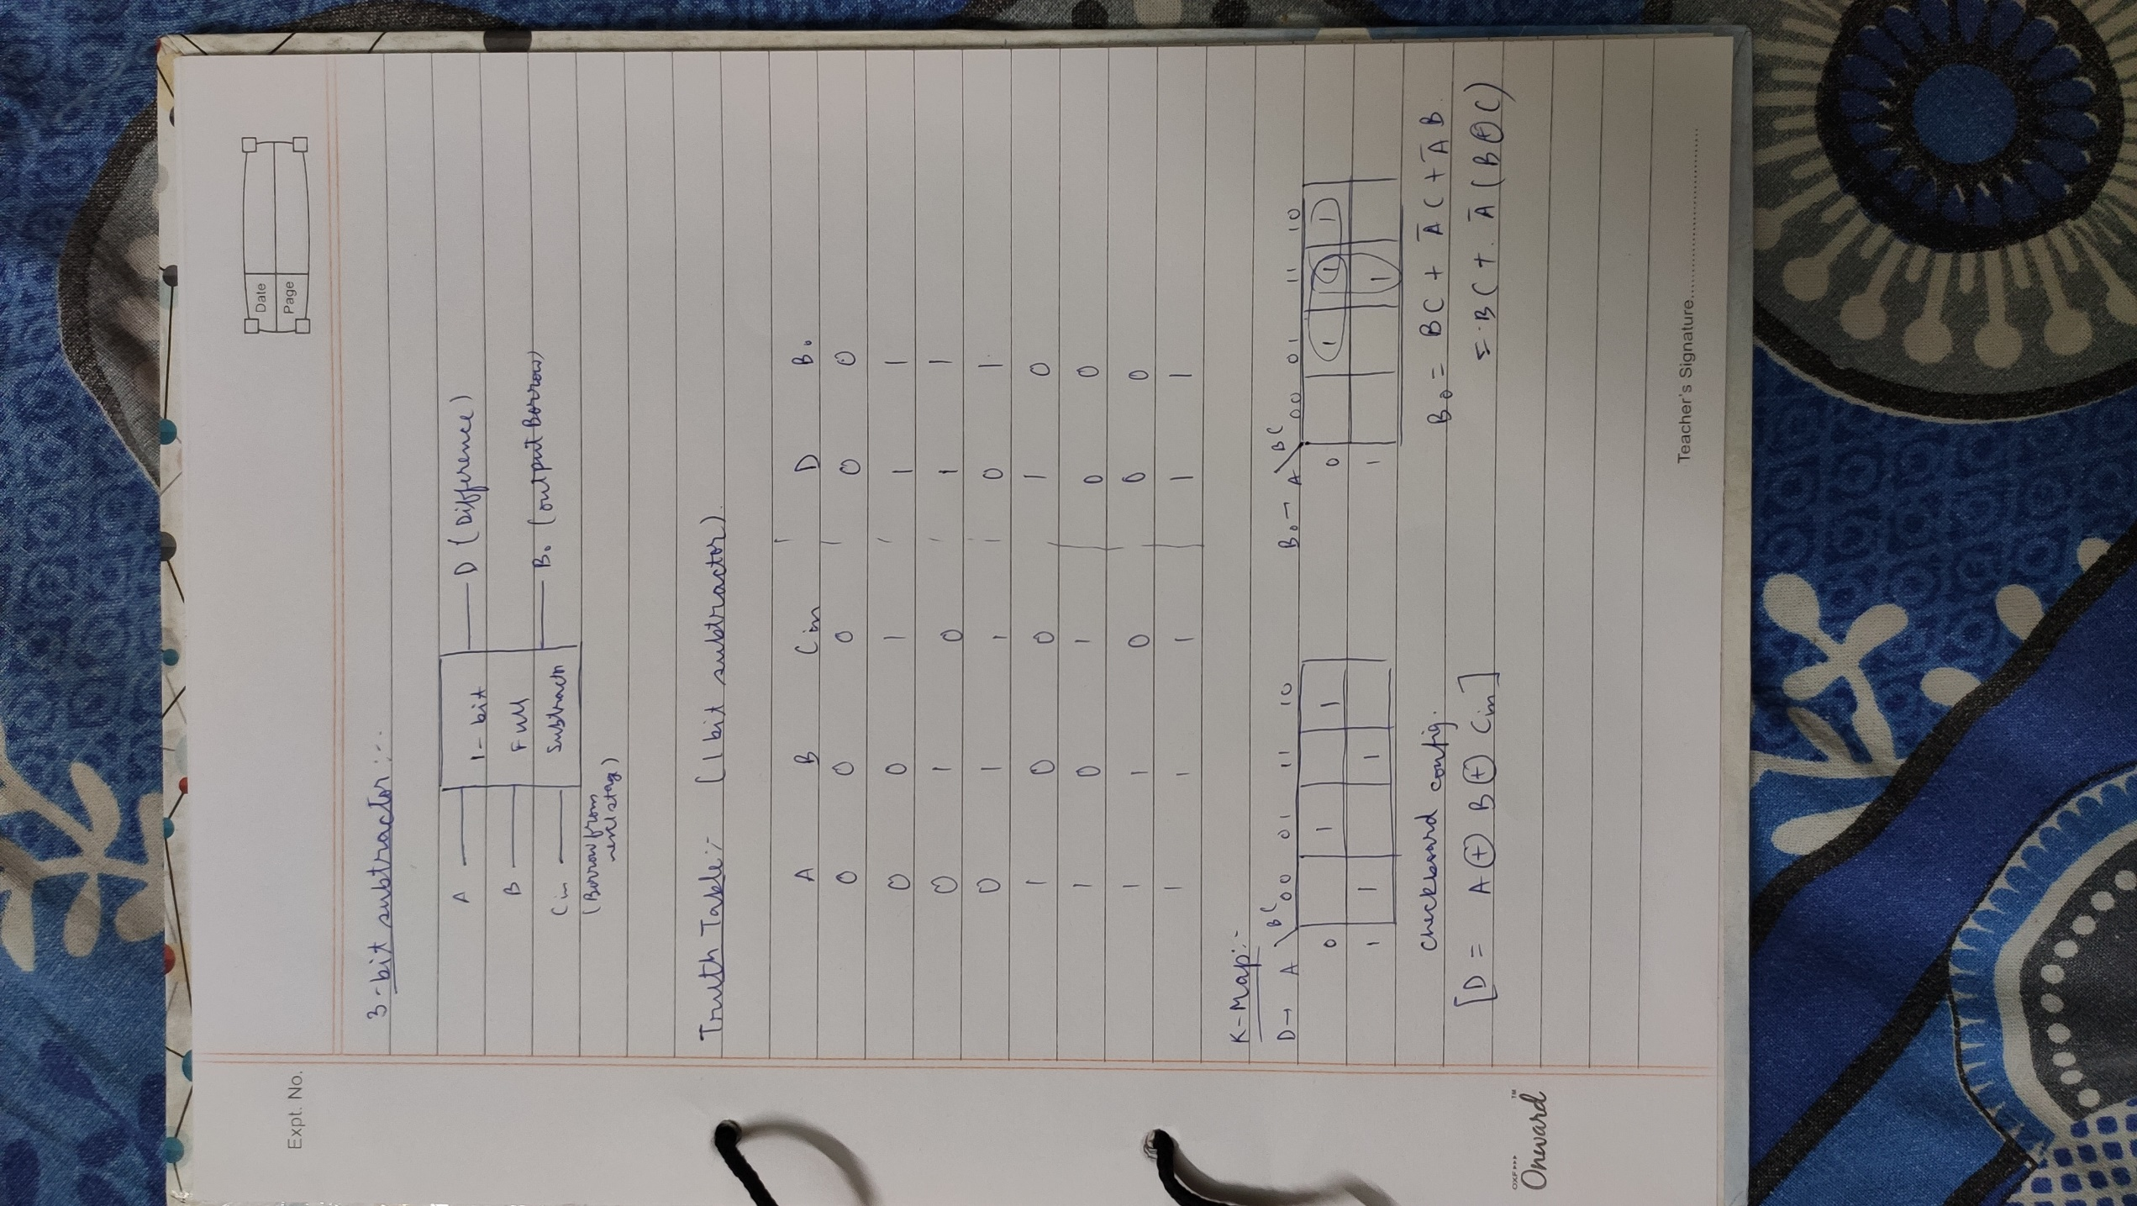

**CIRCUIT DIAGRAM:**

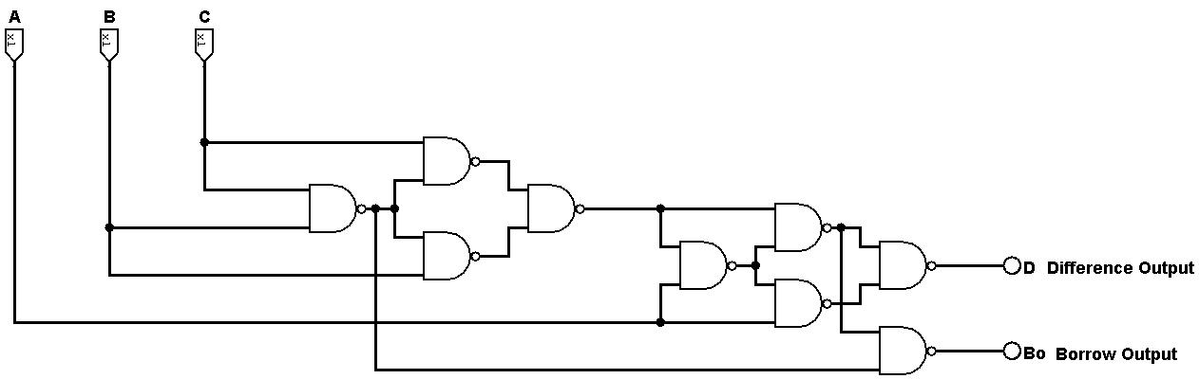**1 BIT FULL SUBTRACTOR:**

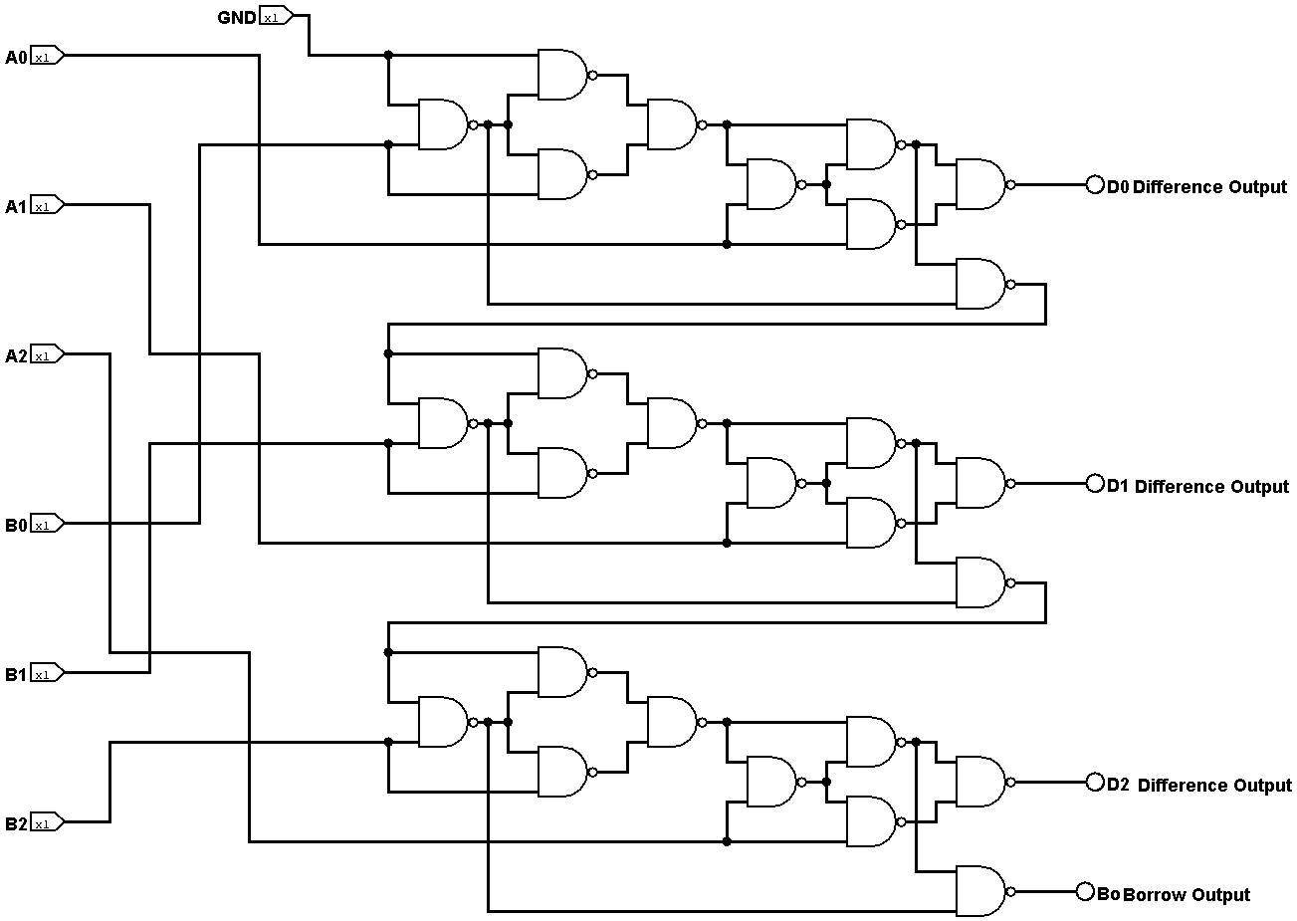**3 BIT FULL SUBTRACTOR:**